**Multiprocessors**

# 1.Characteristics of multiprocessors

* + - A multiprocessor system is an interconnection of two or more CPUs with memory and input-output equipment.
    - The term “processor” in multiprocessor can mean either a central processing unit (CPU) or an input-output processor (IOP).
    - Multiprocessors are classified as *multiple instruction stream, multiple data stream*

(MIMD) systems

* + - The similarity and distinction between multiprocessor and multicomputer are
      * Similarity
        + Both support concurrent operations
      * Distinction
        + The network consists of several autonomous computers that may or may not communicate with each other.
        + A multiprocessor system is controlled by one operating system that provides interaction between processors and all the components of the system cooperate in the solution of a problem.
    - Multiprocessing improves the reliability of the system.
    - The benefit derived from a multiprocessor organization is an improved system performance.
      * Multiple independent jobs can be made to operate in parallel.
      * A single job can be partitioned into multiple parallel tasks.
    - Multiprocessing can improve performance by decomposing a program into parallel executable tasks.
      * The user can explicitly declare that certain tasks of the program be executed in parallel.
        + This must be done prior to loading the program by specifying the parallel executable segments.
      * The other is to provide a compiler with multiprocessor software that can automatically detect parallelism in a user’s program.
    - Multiprocessor are classified by the way their memory is organized.
      * A multiprocessor system with *common shared memory* is classified as a

*shared-memory* or *tightly coupled multiprocessor*.

* + - * + Tolerate a *higher degree* of interaction between tasks.
      * Each processor element with its own *private local memory* is classified as a *distributed-memory* or *loosely coupled system.*
        + Are most efficient when the interaction between tasks is *minimal*

# 2.Interconnection Structures

* + - The components that form a multiprocessor system are CPUs, IOPs connected to input- output devices, and a memory unit.
    - The interconnection between the components can have different physical configurations, depending on the number of transfer paths that are available
      * Between the processors and memory in a shared memory system
      * Among the processing elements in a loosely coupled system
    - There are several physical forms available for establishing an interconnection network.
      * Time-shared common bus
      * Multiport memory
      * Crossbar switch
      * Multistage switching network
      * Hypercube system

# Time Shared Common Bus

* + - A common-bus multiprocessor system consists of a number of processors connected through a common path to a memory unit.
    - *Disadv.*:
      * Only one processor can communicate with the memory or another processor at any given time.
      * As a consequence, the total overall transfer rate within the system is limited by the speed of the single path
    - A more economical implementation of a dual bus structure is depicted in Fig. below.
    - Part of the local memory may be designed as a *cache memory* attached to the CPU.

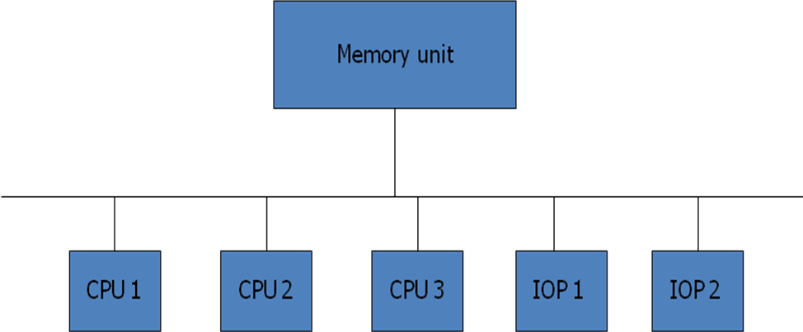

Fig: Time shared common bus organization

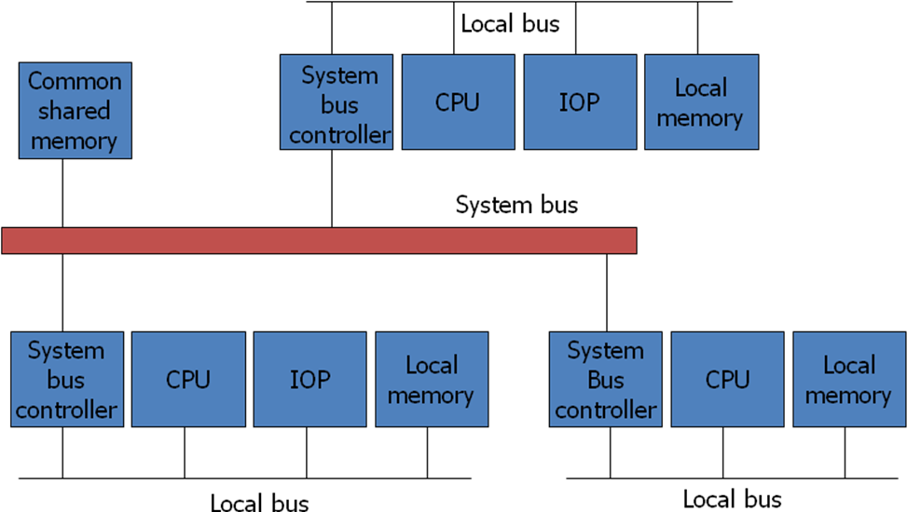

Fig: System bus structure for multiprocessorsa

# Multiport Memory

* + - A multiport memory system employs separate buses between each memory module and each CPU.
    - The module must have internal control logic to determine which port will have access to memory at any given time.
    - Memory access conflicts are resolved by assigning fixed priorities to each memory port.
    - *Adv.*:
      * The high transfer rate can be achieved because of the multiple paths.
    - *Disadv.*:
      * It requires expensive memory control logic and a large number of cables and connections

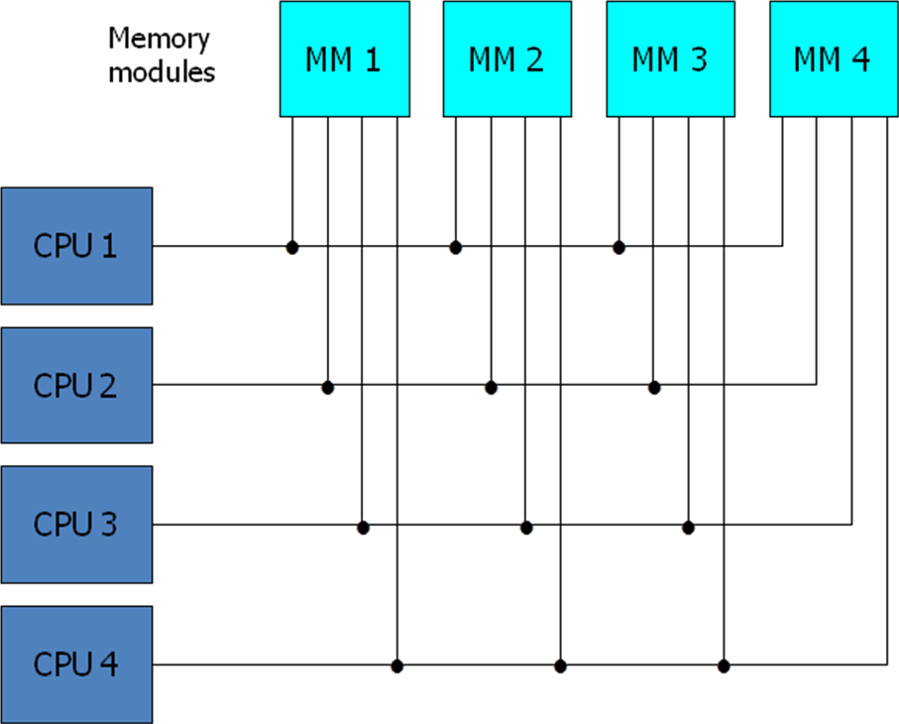

Fig: Multiport memory organization

# Crossbar Switch

* + - Consists of a number of *crosspoints* that are placed at intersections between processor buses and memory module paths.
    - The small square in each crosspoint is a *switch* that determines the path from a processor to a memory module.
    - Adv.:
      * Supports simultaneous transfers from all memory modules
    - Disadv.:
      * The hardware required to implement the switch can become quite large and complex.
    - Below fig. shows the functional design of a crossbar switch connected to one memory module.

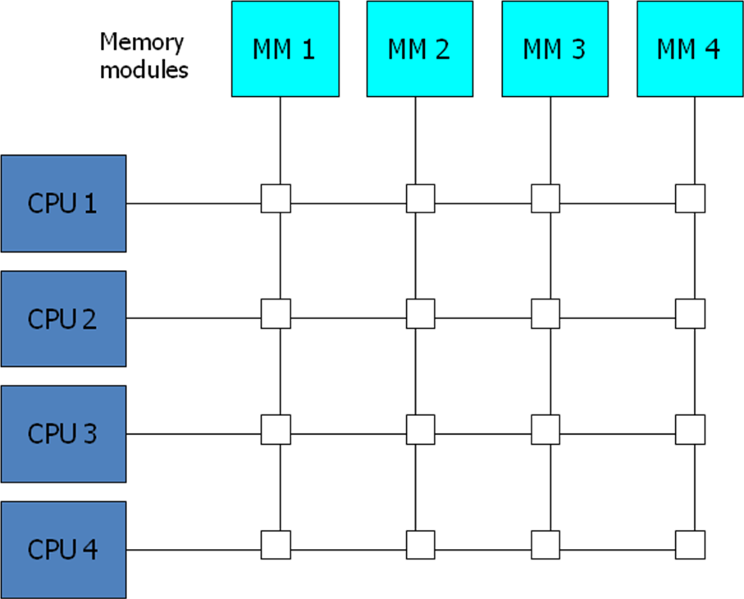

Fig: Crossbar switch

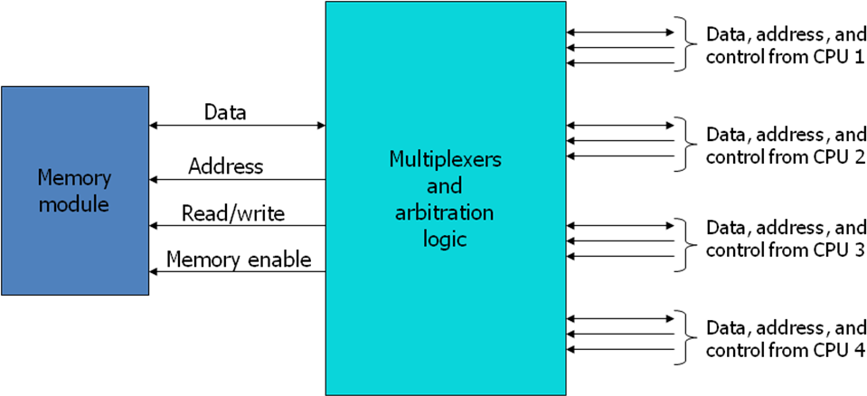

Fig: Block diagram of crossbar switch

# Multistage Switching Network

* + - The basic component of a multistage network is a two-input, two-output interchange switch as shown in Fig. below.

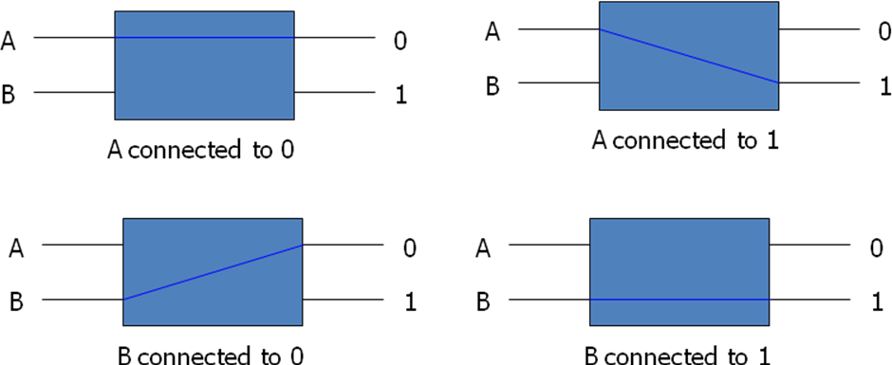

* + - Using the 2x2 switch as a building block, it is possible to build a multistage network to control the communication between a number of sources and destinations.
      * To see how this is done, consider the binary tree shown in Fig. below.
      * 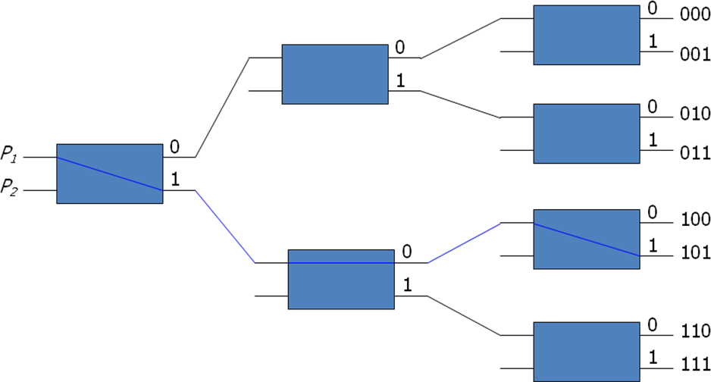Certain request patterns cannot be satisfied simultaneously. i.e., if P1 → 000~011, then P2 → 100~111
    - One such topology is the omega switching network shown in Fig. below

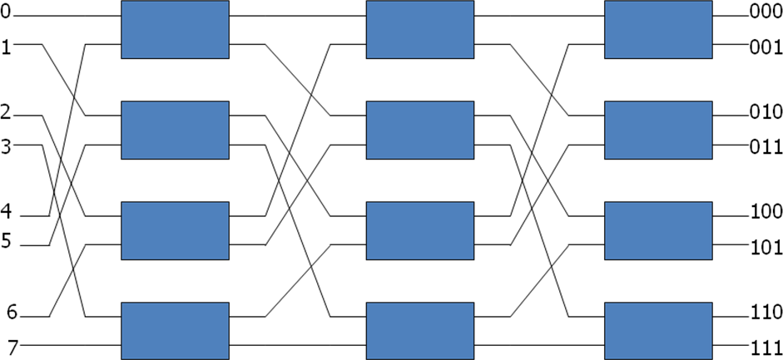.

Fig: 8 x 8 Omega Switching Network

* + - Some request patterns cannot be connected simultaneously. i.e., any two sources cannot be connected simultaneously to destination 000 and 001
    - In a tightly coupled multiprocessor system, the source is a processor and the destination is a memory module.
    - Set up the path → transfer the address into memory → transfer the data
    - In a loosely coupled multiprocessor system, both the source and destination are processing elements.

# Hypercube System

* + - The hypercube or binary n-cube multiprocessor structure is a loosely coupled system composed of N=2n processors interconnected in an n-dimensional binary cube.
      * Each processor forms a node of the cube, in effect it contains not only a CPU but also local memory and I/O interface.
      * Each processor address differs from that of each of its n neighbors by exactly one bit position.
    - Fig. below shows the hypercube structure for n=1, 2, and 3.
    - Routing messages through an *n*-cube structure may take from one to *n* links from a source node to a destination node.
      * A routing procedure can be developed by computing the exclusive-OR of the source node address with the destination node address.
      * The message is then sent along any one of the axes that the resulting binary value will have 1 bits corresponding to the axes on which the two nodes differ.
    - A representative of the hypercube architecture is the Intel iPSC computer complex.
      * 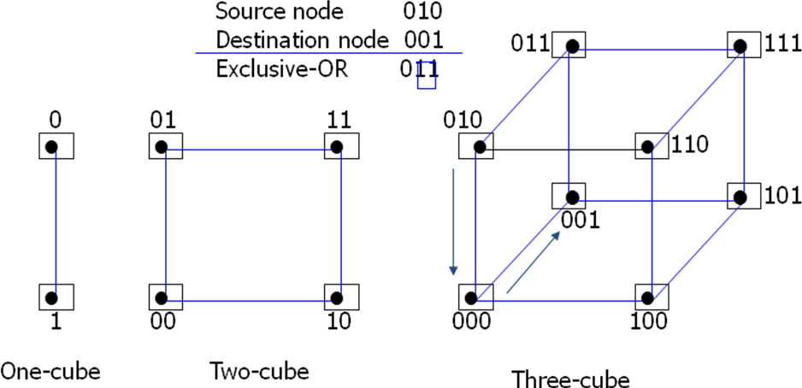It consists of 128(*n*=7) microcomputers, each node consists of a CPU, a floating- point processor, local memory, and serial communication interface units.

Fig: Hypercube structures for n=1,2,3

# 3.Inter processor Communication and Synchronization

* + - The various processors in a multiprocessor system must be provided with a facility for

*communicating* with each other.

* + - * A communication path can be established through *a portion of memory* or *a common input-output channels*.
    - The sending processor structures a request, a message, or a procedure, and places it in the memory mailbox.
      * *Status bits* residing in common memory
      * The receiving processor can check the mailbox *periodically*.
      * The response time of this procedure can be time consuming.
    - A more efficient procedure is for the sending processor to alert the receiving processor directly by means of an *interrupt signal*.
    - In addition to shared memory, a multiprocessor system may have other shared resources. e.g., a magnetic disk storage unit.
    - To prevent conflicting use of shared resources by several processors there must be a provision for assigning resources to processors. i.e., operating system.
    - There are three organizations that have been used in the design of operating system for multiprocessors: *master-slave configuration*, *separate operating system*, and *distributed operating system*.
    - In a master-slave mode, one processor, master, always executes the operating system functions.
    - In the separate operating system organization, each processor can execute the operating system routines it needs. This organization is more suitable for *loosely coupled systems*.
    - In the distributed operating system organization, the operating system routines are distributed among the available processors. However, each particular operating system function is assigned to only one processor at a time. It is also referred to as a *floating operating system*.

# Loosely Coupled System

* There is *no shared memory* for passing information.
* The communication between processors is by means of message passing through *I/O channels*.
* The communication is initiated by one processor calling a *procedure* that resides in the memory of the processor with which it wishes to communicate.
* The communication efficiency of the interprocessor network depends on the *communication routing protocol, processor speed, data link speed, and the topology of the network*.

# Interprocess Synchronization

* + - The instruction set of a multiprocessor contains basic instructions that are used to implement communication and synchronization between cooperating processes.
      * Communication refers to the exchange of data between different processes.
      * Synchronization refers to the special case where the data used to communicate between processors is control information.
    - Synchronization is needed to enforce the *correct sequence of processes* and to ensure

*mutually exclusive access* to shared writable data.

* + - Multiprocessor systems usually include various mechanisms to deal with the synchronization of resources.
      * Low-level primitives are implemented directly by the hardware.
      * These primitives are the basic mechanisms that enforce mutual exclusion for more complex mechanisms implemented in software.
      * A number of hardware mechanisms for mutual exclusion have been developed.
        + A binary semaphore

# Mutual Exclusion with Semaphore

* + - A properly functioning multiprocessor system must provide a mechanism that will guarantee orderly access to shared memory and other shared resources.
      * Mutual exclusion: This is necessary to protect data from being changed simultaneously by two or more processors.
      * Critical section: is a program sequence that must complete execution before another processor accesses the same shared resource.
    - A *binary variable* called a *semaphore* is often used to indicate whether or not a processor is executing a critical section.
    - Testing and setting the semaphore is itself a critical operation and must be performed as a single indivisible operation.
    - A semaphore can be initialized by means of a *test and set instruction* in conjunction with a hardware *lock* mechanism.
    - The instruction TSL SEM will be executed in two memory cycles (the first to read and the second to write) as follows: R ← M[*SEM*], M[*SEM*] ← 1
    - Note that the lock signal must be active during the execution of the test-and-set instruction.